Downloading Microsoft Office 365
Follow these steps to get access to Microsoft Office 365 for your computer.

1) Go to http://west.lethsd.ab.ca

2) Click on Quick Links
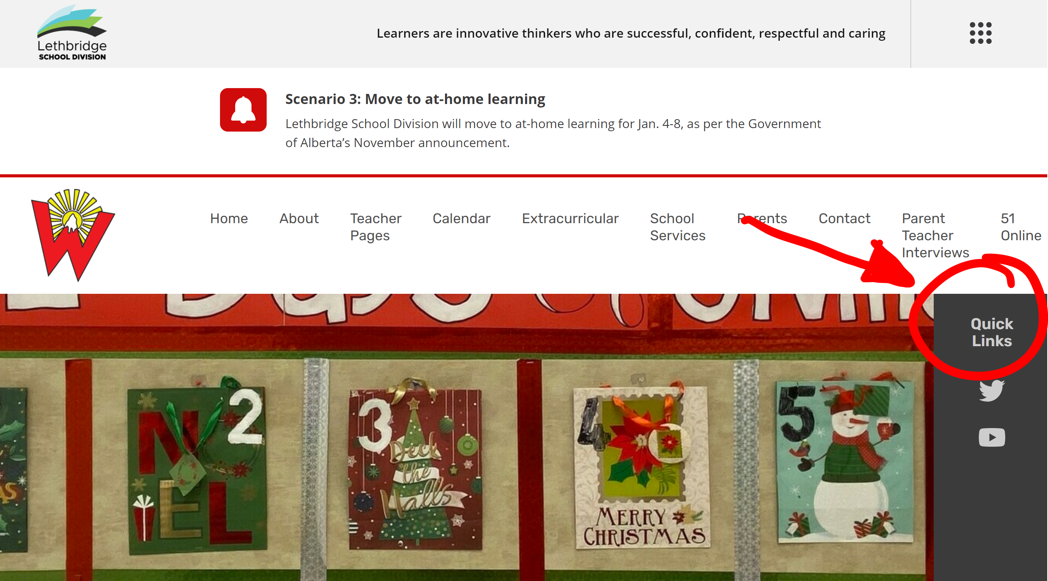

3) Click on Office365 Webmail.
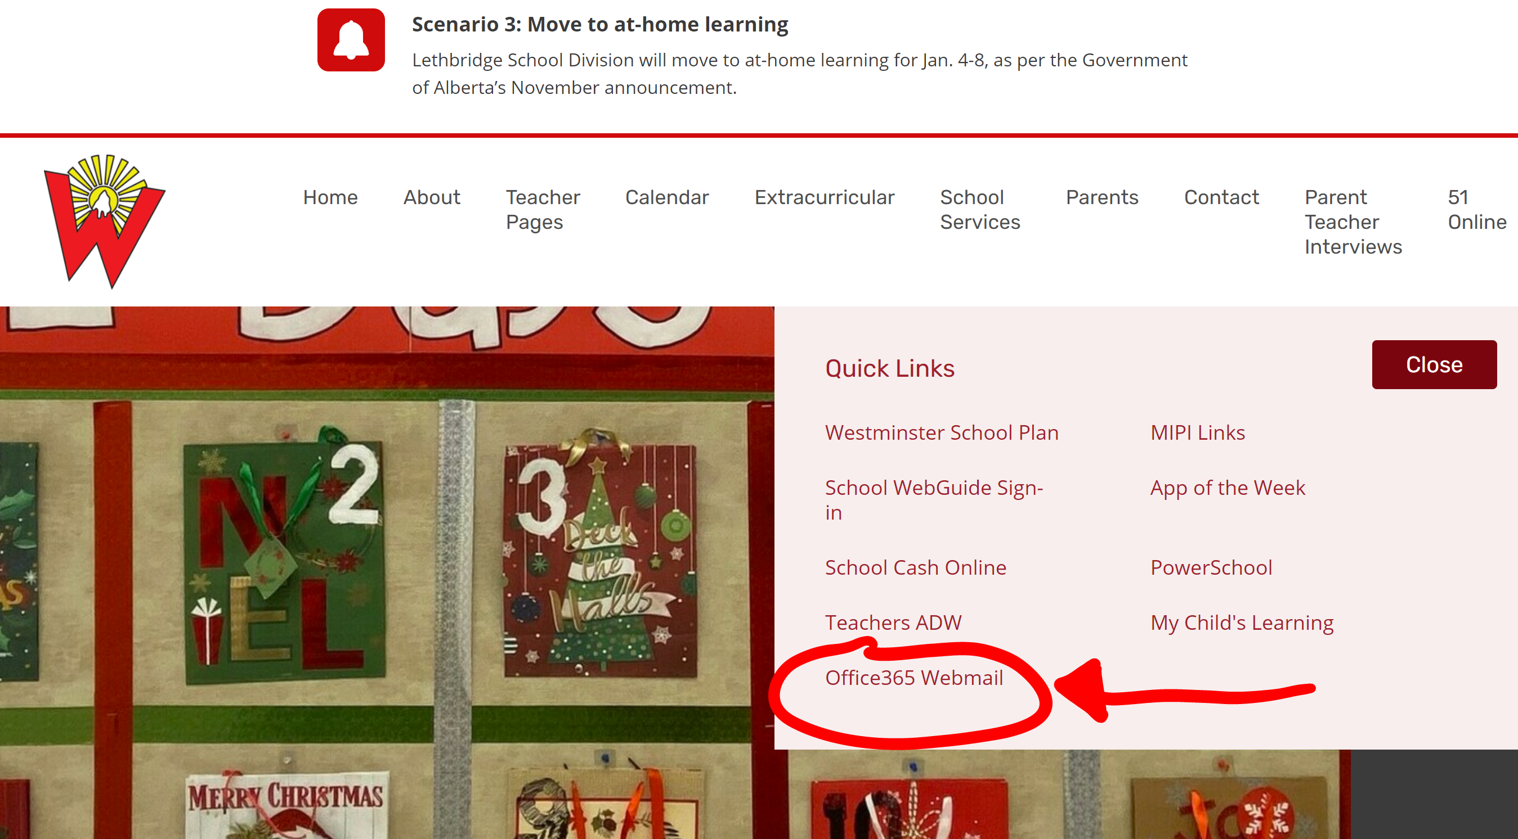

4) Log in with student information
(Username: john.doe(gradyear)@lethsd.ab.ca)
(Password: your students Alberta School Number).
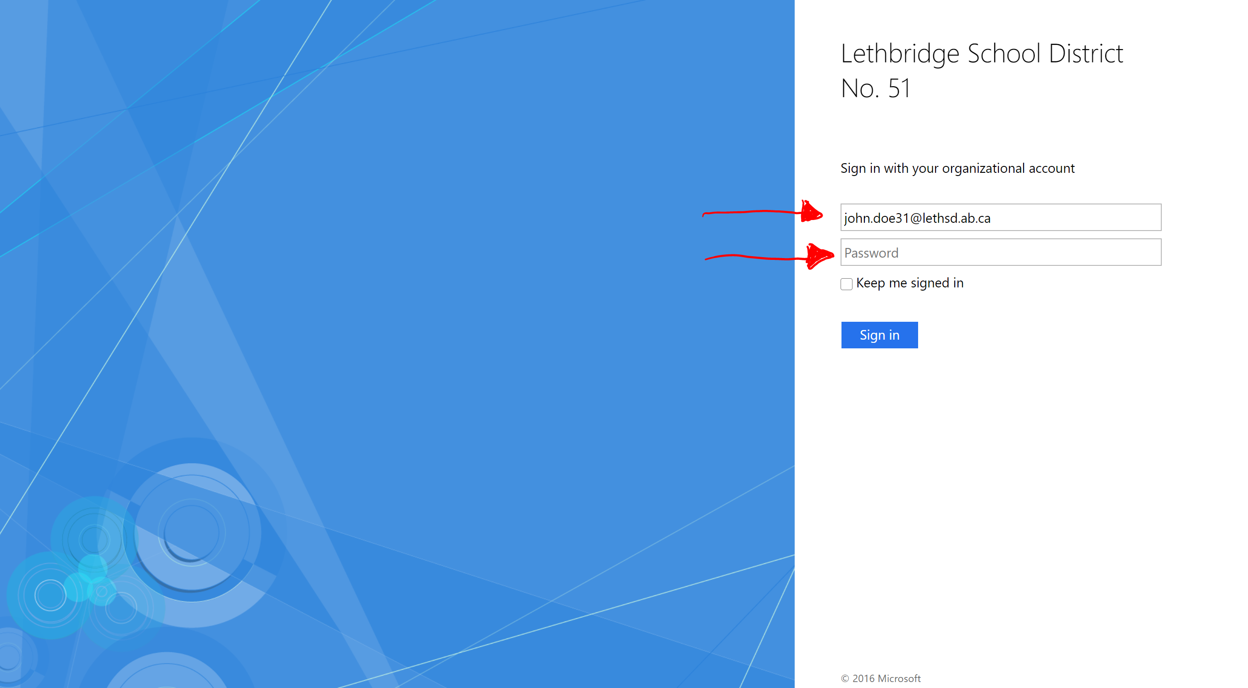
5) Click the “Waffle” icon in the top left corner.

6) Click “Office 365” in the top right corner of that menu.
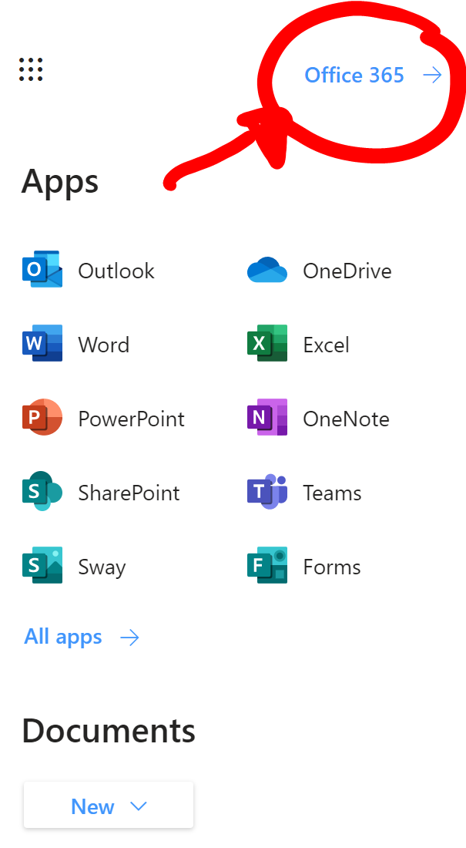

7) Click “Install Office 365” in the top right corner.

